Face recognition attendance system

Project on

“Face recognition attendance system”

**In partial fulfilment of the requirement for award of the degree of**

**BACHLEOR OF BUISNESSADMINSTRATION**

**(COMPUTER APPLICATION)**

By

Miss. Neha Sanjay Shinde Roll no:78

Miss. Sakshi Rajendra Saste Roll no:74



**Project guide:**

**Mr. Anil kalokhe**

**VIDYA PRATISHTHAN’S**

**ARTS, SCIENCE & COMMERCE COLLAGE,**

**VIDYANAGRI, BARAMATI-413133**

**SAVITRIBAI PHULE PUNE UNIVERSITY,PUNE**

**TYBBA(CA)-(Sem V) 2023-2024**

**VIDYA PRATISHTHAN**

**ARTS, SCIENCE & COMMERCE COLLEGE**

**VIDYANAGRI, BHIGWAN ROAD BARAMATI, DIST-PUNE (413133)**



**CRETIFICATE**

**DEPARTMENT OF B.B.A (COMPUTER APPLICATION)**

This is to certify that Saste Sakshi Rajendra & Shinde Neha Sanjay of TYBBA(CA) has satisfactory carried out the project work according to the syllabus prescribed by the Savitribai Phule Pune University in BBA (Computer Application) & this project represents his Bonafide work in the year 2023 to 2024.

Roll no: 74 Examination Seat no:

Roll no: 78 Examination Seat no:

Batch in charge H.O.D

Date: / / Date: / /

Internal examiner external examiner

Date: / / Date: / /

**INDEX**

|  |  |
| --- | --- |
| **SR.NO** | **CONTENT** |
| **Ch.1** | **Introduction** |
| 1.1 | Company profile |
| 1.2 | Introduction of the system |
| 1.3 | Scope of system |
| 1.4 | Propose of system |
|  |  |
| **Ch.2** | **Analysis** |
| 2.1 | Fact finding technique |
| 2.2 | Feasibility study |
|  |  |
| **Ch.3** | **System design** |
| 3.1 | Entities |
| 3.2 | ERD |
| 3.3 | Context Level Diagram |
| 3.4 | First Level DFD |
| 3.5 | Second Level DFD |
|  |  |
| **Ch.4** | **File design** |
| **Ch.5** | **Table design** |
| **Ch.6** | **Form design** |
| **Ch.7** | **Report** |
| **Ch.8** | **Advantages and limitation** |
| **Ch.9** | **Future Enhancement** |
| **Ch.10** | **Bibliography** |

CHAPTER NO :1

Introduction

* 1. **Company Profile:**

Vidya Pratishthan’s is charitable trust established on 16th October 1972 to provide affordable quality education to the students of Baramati and vicinity area at their doorsteps.

Face recognition can Vidya store data of infinity number of student and also help to store daily attendance of student

**1.2 Introduction To System**

A face recognition attendance system is a facial recognition technology to recognize and verify an student facial features and to record attendance automatically. Face detection attendance system detects the facial expressions of student and marks attendance. face recognition is used in various company, organization, school, college, bank and other enterprises. Traditional method of attendance marking is a tedious task in many schools and colleges. This is time consuming but face recognition save time and automatically mark the attendance and save record in database.

* 1. **Scope Of System**
* Provides an automated attendance system ,reliable and eliminate disturbance and time loss of traditional attendance systems
* Present a system that can accurately evaluate student's performance depending on their recorder attendance rate
* Present a system that can accurately evaluate student's performance depending on their recorded attendance
* Regular maintenance and technical support are necessary to ensure the system functions correctly over time.

**1.4 Proposed System**

The system consists of a camera that capture the image of the students and send it to the image enhancement module .After enhancement the image comes in the face detection and recognition modules and then the attendance is marked on the excel sheet.

* Reduce the paper work
* Less time consuming.
* Provides quick & faster result with better accuracy.

ADVANTAGE:

* Reduce paperwork and save time
* Eliminates Duplicate data entries
* Increased privacy and security where student cannot present himself or his friend while they are not
* Reduce manual process errors and provides a reliable attendance system

CHAPTER NO :2

Analysis

**2.1 Fact finding techniques** :

There are fact finding techniques related to “Face recognition Attendance System

* Interview
* Record view
* Observation
* **Interviewing :-**

We use this technique frequently in the system analysis because the technique is best method for producing the qualitive information and allow us to discover are area to proposed system the interview are structured and unstructured analysis users interview to collect information from individual there are two types interview.

* + - **Structured Interview**

We select this method for the interview but at the time of actual interview this method is not works on it so we change this methods and select the unstructured interview.

* + - **Unstructured Interview**

An unstructured interview is an interview without any set format but in which the interviews may we have to use for gathering information about organization.

In interview we will take the interview of Mr Pawar in that we ask some questions.

1. How many student are studing in bba ca department?
2. How many classes are in this deparment?
3. Which type of method used for attendance?
4. How do you record student information?

* **Record View**

Creating a record view for a face recognition attendance system involves designing a user interface that allows administrators or users to view attendance records.

* **Observation**

Face recognition attendance systems use computer vision and facial recognition technology to track and record attendance

**2.2 Feasibility study :**

A feasibility study is a high-level capsule version of entire. System analysis and Design process .The study beings by classifying the problem definition. Feasibility is to determine if it’s worth doing. Once an acceptance problem definition has been generated ,the analyst develops a logical model of the A search of alternative is analyzed carefully.

Technical study:

* **Hardware & Software Requirement :-**

**a. Hardware Requirement :-**

* IP camera/web Camera
* Laptop with 8 GB RAM or above
* Secondary memory to store all images and database

**b. Software Requirement :-**

* Windows 8 or Higher
* Visual Studio Code
* Latest Version Of All Libraries
* Tkinter

Economical Feasibility :

The system developed and install will be good benefit to organization the system be developed and operated in the existing hardware and software infrastructure so there is no need of additional hardware and software for the system

Operational feasibility :

Question and going to be asked are:

* Will the system be used if it developed and implemented?
* If there was sufficient support for the project form the users.
* Have the user been involved in planning and development of the project
* Will the system produce poor result in any respects or area?

This is team can be implemented in the organisation because there is adjective support from management and user being developed in Python so that is necessary operation are carried out automatically

CHAPTER NO :3

System Design

**3.1 Entity and Attributes:**

|  |  |  |
| --- | --- | --- |
| **Sr No** | **Entity** | **Attribute** |
| 1 | Department | d_id , d_name |
| 2 | Student | Sid , sname |
| 3 | Recognition enrollment | id , name |

**3.2 Entity and Relationship :**

|  |  |  |
| --- | --- | --- |
| **Sr no** | **Entity** | **Relationship** |
| 1 | Department to student | One to many |
| 2 | Student to enrollment | One to one |
| 3 | Student to face recognition | One to one |

**3.3 ER Diagram :**

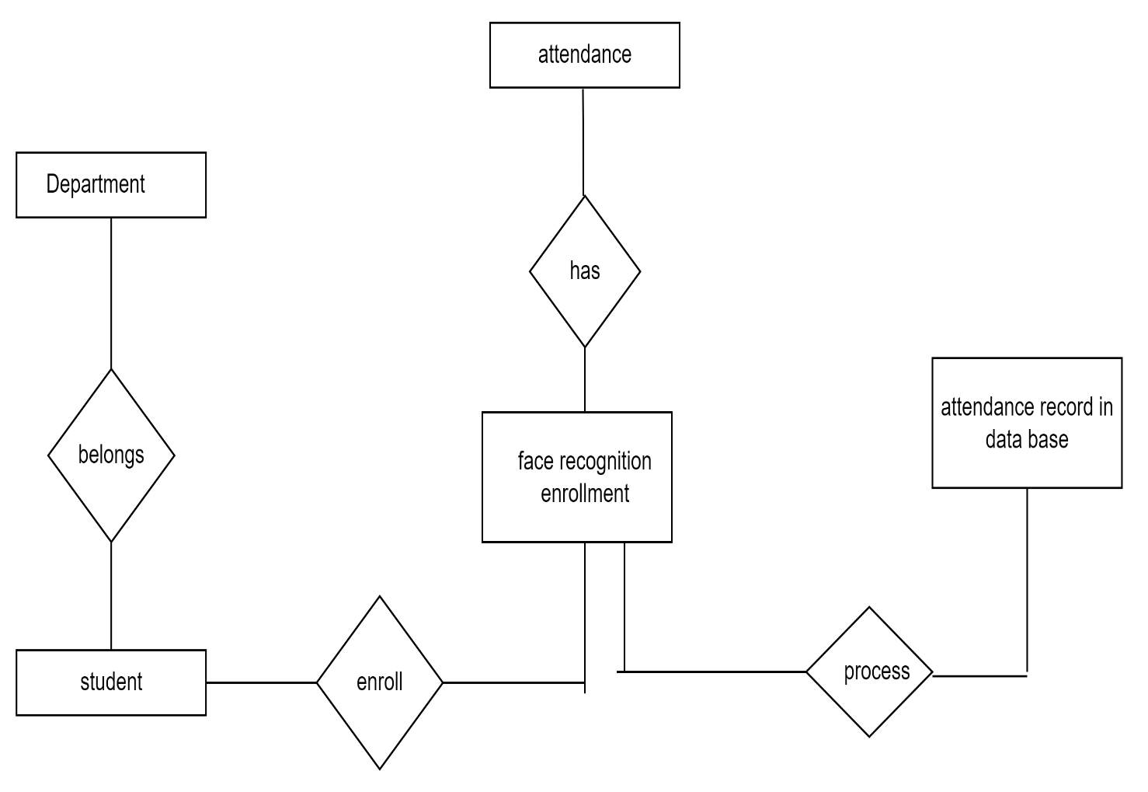

**3.4 Context Level Dfd :**

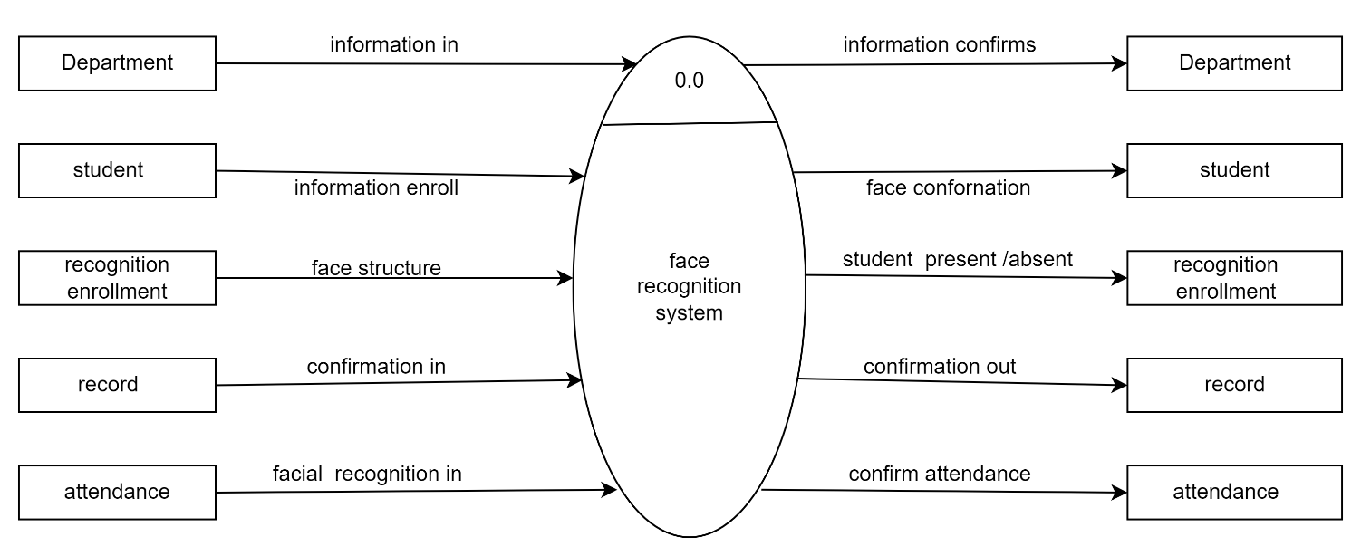

**3.5 First Level Dfd :**

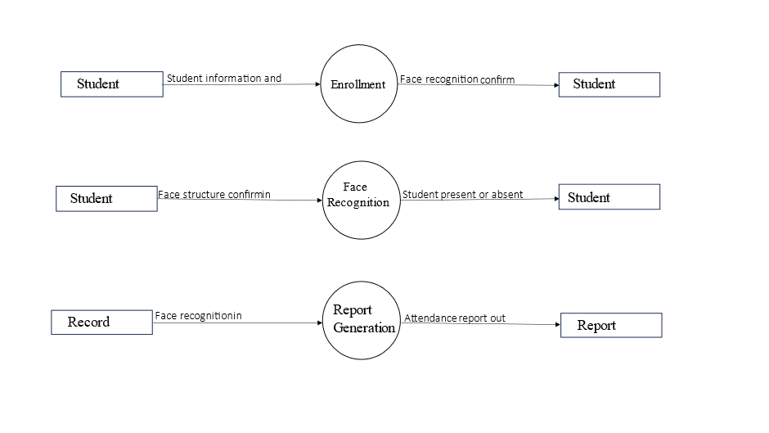

**3.5 Second Level Diagram :**

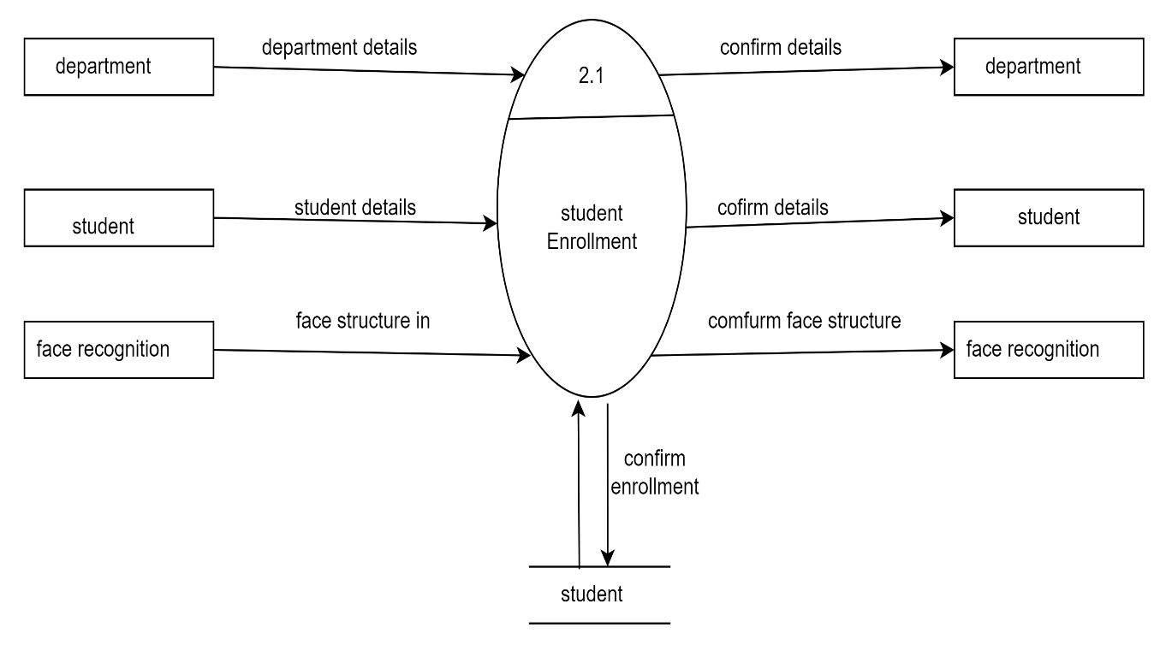

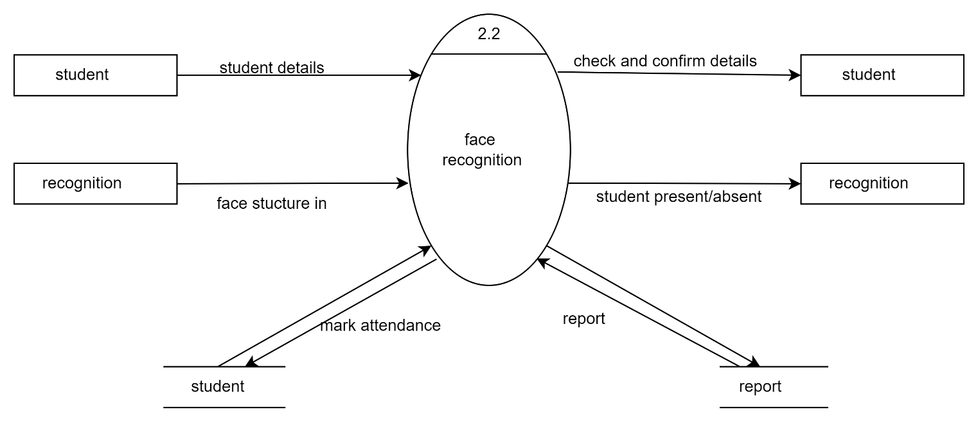

CHAPTER NO :4

File Design

**Department**

|  |  |  |  |  |  |  |
| --- | --- | --- | --- | --- | --- | --- |
| **Data Elements** | **Description** | **Data type** | **size** | **List of specific values** | **Data store** | **Remarks** |
| d_id | Department id | Number | 10 | Department id | Department id | It contain all number |
| d_name | Department name | Text | 20 | Department name | Department name | It contain text |

**Student**

|  |  |  |  |  |  |  |
| --- | --- | --- | --- | --- | --- | --- |
| **Data Elements** | **Description** | **Data type** | **size** | **List of specific values** | **Data store** | **Remarks** |
| sid | Student id | Number | 10 | Student id | Student name | It contain all number |
| sname | Student name | Text | 20 | Student name | Student name | It contain all text |

**Recognition**

|  |  |  |  |  |  |  |
| --- | --- | --- | --- | --- | --- | --- |
| **Data Elements** | **Description** | **Data type** | **size** | **List of specific values** | **Data store** | **Remarks** |
| id | id | Number | 10 | id | id | It contain all number |
| name | name | Text | 20 | name | name | It contain all text |

CHAPTER NO :5

Table Design

**Table name : Department**

|  |  |  |  |  |  |
| --- | --- | --- | --- | --- | --- |
| **Sr no** | **Attribute** | **datatype** | **size** | **constraint** | **description** |
| 1 | d_id | numbar | 5 | Primary key | Department id |
| 2 | d_name | Text | 20 | Not null | Department name |

**Table name : student**

|  |  |  |  |  |  |
| --- | --- | --- | --- | --- | --- |
| **Sr no** | **Attribute** | **datatype** | **size** | **Constraint** | **description** |
| 1 | sid | number | 5 | Primary key | Student number |
| 2 | sname | text | 20 | Not null | Student name |

**Table name : Enrollment**

|  |  |  |  |  |  |
| --- | --- | --- | --- | --- | --- |
| **Sr no** | **Attribute** | **datatype** | **size** | **Constraint** | **description** |
| 1 | id | number | 5 | Not null | Enrollment id |
| 2 | name | text | 20 | Not null | Name used for enrollment |

CHAPTER NO :6

Form Design

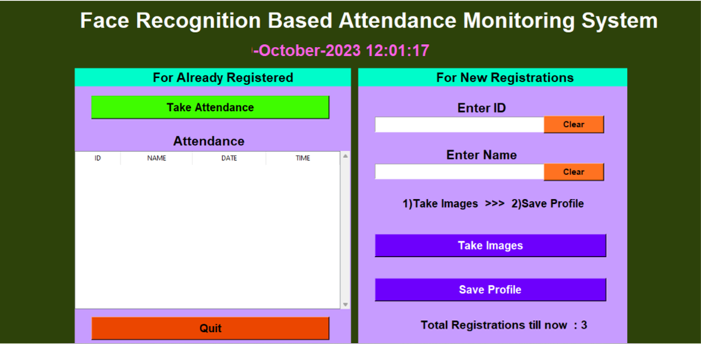

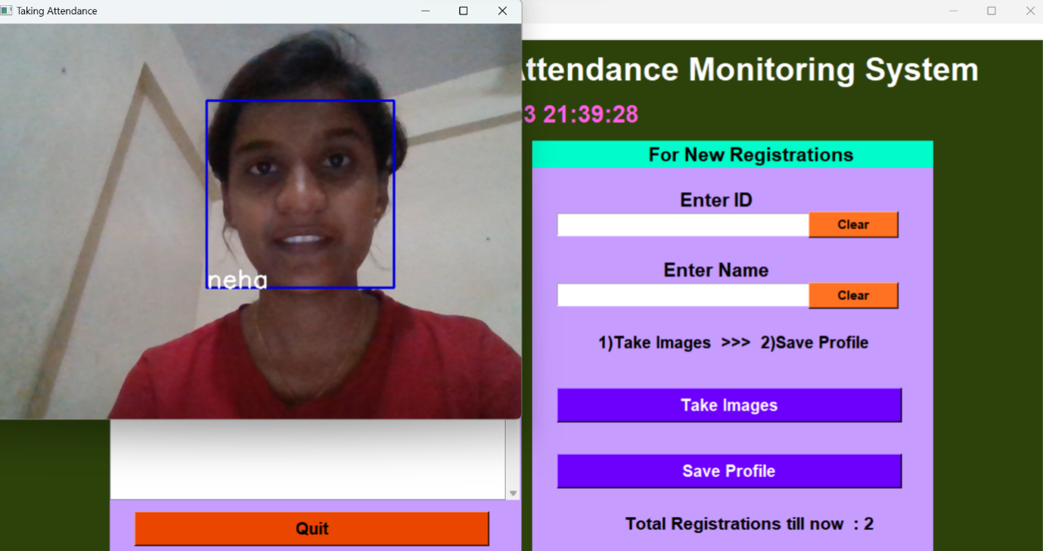

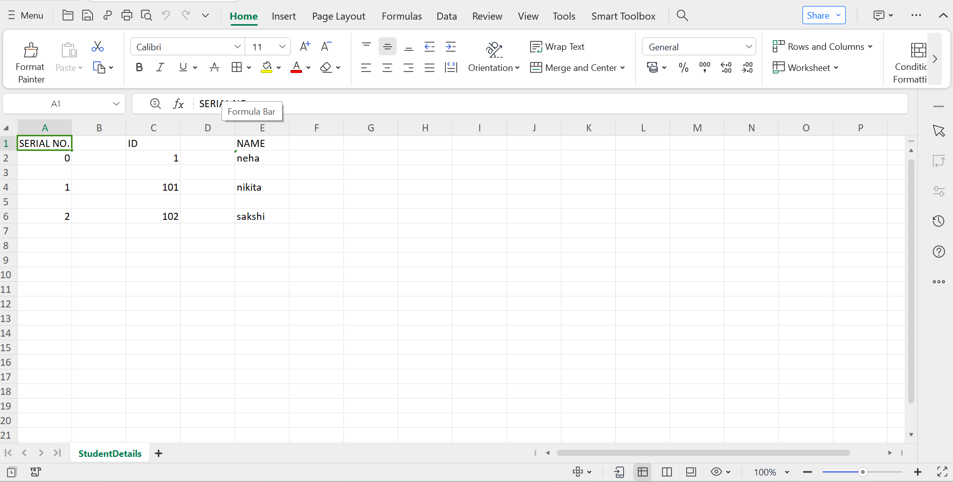

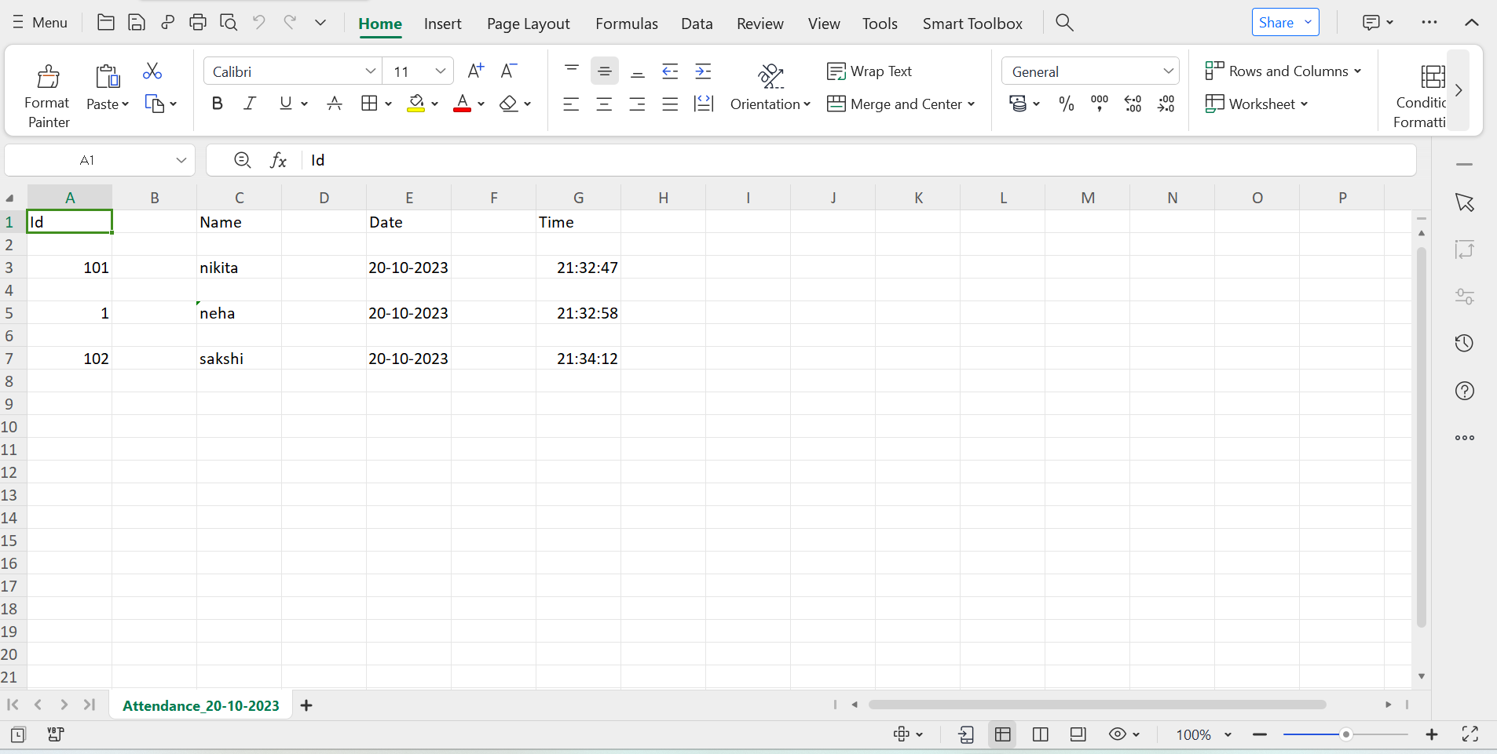

CHAPTER NO :7

Report

**REPORT**

|  |  |  |  |  |
| --- | --- | --- | --- | --- |
| **Sr no** | **id** | **Name** | **Class** | **Present/absent** |
| 1 | 1 | Neha shinde | TYBBACA | present |
| 2 | 101 | Nikita Devkar | TYBBACA | present |
| 3 | 02 | Rutuja bandgar | TYBBACA | present |
| 4 | 03 | Sakshi saste | TYBBACA | present |
| 5 |  |  |  |  |

CHAPTER NO :8

Advantages And Limitation

**Advantages :**

* Reduce paperwork and save time .
* Eliminates Duplicate data entries.
* Increased privacy and security where student cannot present himself or his friend while they are not.
* Reduce manual process errors and provides a reliable attendance system.
* It is highly accurate in identifying individuals,reducing the chance of errors or fraulent attendance records.
* Automated time tracking system and also reduces manual effort.

**Limitation :**

* Problem with false rejection when people change their hairstyle grow or shave a beer or wear glasses.
* Face recognition system can't tell the difference between identical twins

CHAPTER NO :9

Future Enhancement

**Future Enhancement :-**

* The system we have development has successfully, able to accomplish the task of marking the attendance in the classroom automatically and output is obtained in an excel sheet as desired in real-time.
* However, in order to develop a dedicated system which can be implemented in an educational institution, a very efficient algorithm which is insensitive to the lighting condition of the classroom has to be developed. Also a camera of optimum resolution has to be utilized in the system. Another important aspect where we can a work towards is to creating an online database of the attendance and the automatic update of the attendance.
* This can be done by creating a standalone module which can be installed in the classroom having access to internet, preferably a wireless system. This development can greatly improve the application of the project.

CHAPTER NO :10

Bibliography

* Website :

[www.googole.com](http://www.googole.com)

[www.youtube.com](http://www.youtube.com)

[www.chatgpt.com](http://www.chatgpt.com)